The following questions are based off the goals for M02 L05 discussing Predefined Classes, Objects and Methods and I/O:

*Goals:*

* *Standard Library Packages, Classes and Methods* 
  + *Find and use documentation (API) in Eclipse for the core libraries*
  + *Explain* 
    - *predefined classes, objects and methods*
    - *methods, parameters, arguments*
  + *Identify packages, classes and methods in code and apply in code*
  + *Explain and develop code that constructs objects and calls their methods to perform operations.*
* *Standard Input and Output (I/O) Input/Output*
  + *Describe standard input and output streams*
  + *Create code to display information to the console and format output and read information from the keyboard*
* *Quality Code* 
  + *Use your IDE to debug and clean up warnings*

**Note**: Feel free to continue exploring these goals and the lecture in a way that *makes sense to you*.



1. What are naming conventions for a class name? (*Hint*: think class versus a variable? How can we tell its *specifically* a class name?)
2. How do you create a scanner object called input (*Hint*: Check lecture for example)
   1. In Eclipse, after creating the object, start a new line by typing “[input.ne](http://input.ne)” . Explore the API that comes up
3. How do I take in a String input from a user using my new scanner object? (*Hint*: Use the api explored in question 2).
   1. How would I take in a Double input?
   2. How would I take in an Int input?
4. Notice the API below that I accessed for a String labeled dogName.

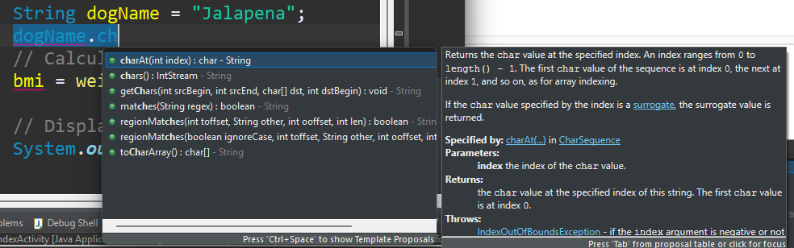

* 1. What is the method highlighted?
  2. What are the parameters? How do you know?
  3. Specify a valid argument I can pass into the method

1. The print statement below has an error because it is missing something.



* 1. What is it missing? What is the significance of that missing code? (Hint: visit slides about I/O)



* 1. The creation of the Scanner object above doesn’t work because it’s missing something. What is it missing? What is the significance of that missing code?

1. Using **printf()** and the variable dogName from above, how can I print “Jalapena is cute” in the console?
2. Attempt the BodyMassIndexActivity.java Lab from your class examples